**Create Scheduled Tasks with Azure Functions SOP**

1. **Create an Azure Function App: a. Resource Group: --RG b. Publish: Code c. Runtime Stack: .NET Core d. Region: Central US (Example) e. OS: Windows f. Plan type: Consumption (Serverless) g. Click on Review and Create.**A screenshot of a computer

   AI-generated content may be incorrect.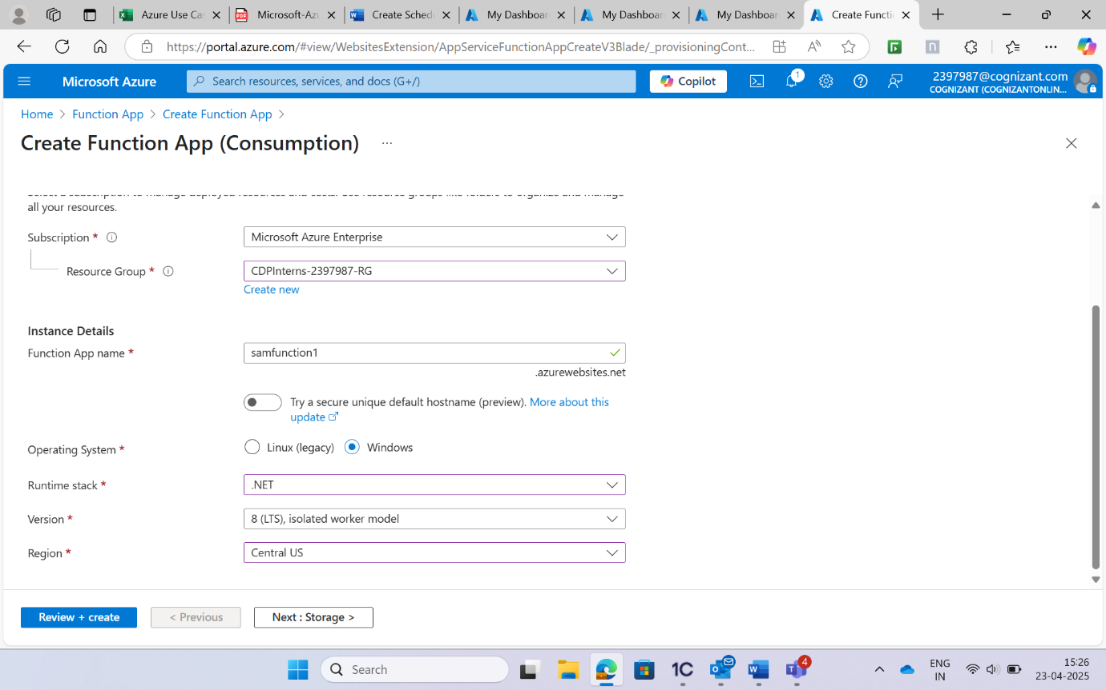A screenshot of a computer

   AI-generated content may be incorrect.A screenshot of a computer

   AI-generated content may be incorrect. **Go to the created function app > Functions > Add > Timer Trigger**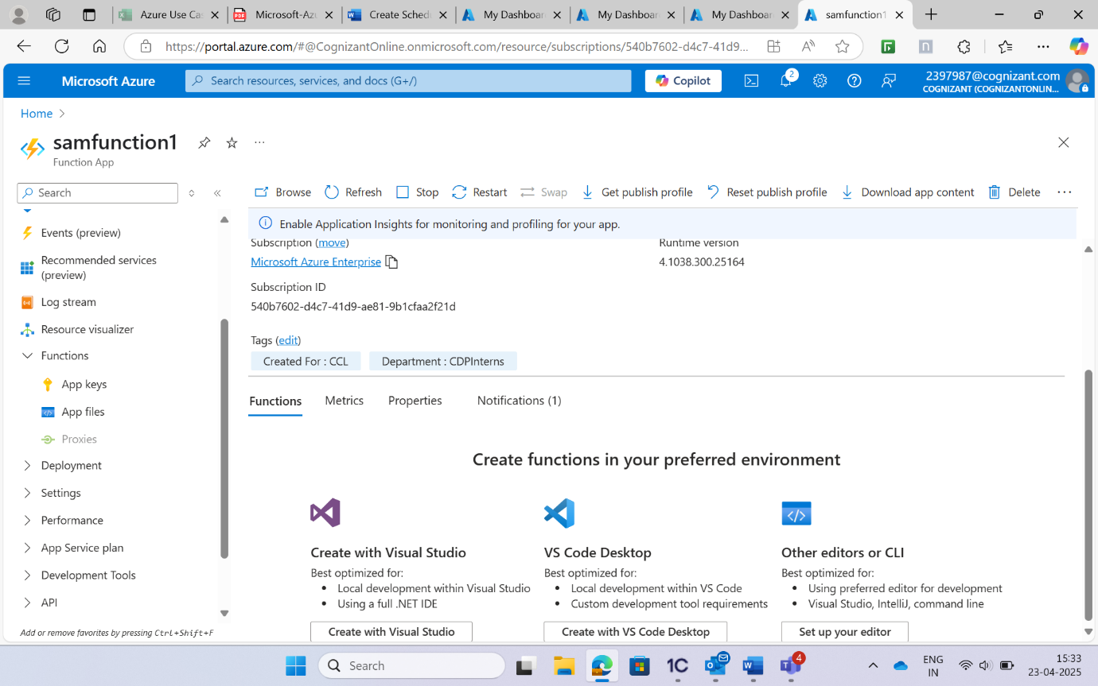A screenshot of a computer

   AI-generated content may be incorrect.